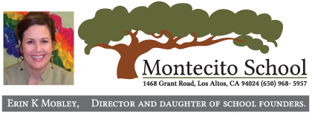

Pre-Enrollment Information for
2022-2023 School Year
Dear Parents:
We are pleased to announce that Montecito’s enrollment for the 2022-2023 school year has begun! Enrollment will begin on Monday, November 15, 2021. We encourage families to enroll at their earliest convenience so they can get the classes and the schedule(s) of their choice.
Attached to this letter is our new List of Fees, an Application for Enrollment and an Admissions Agreement. You will also receive a soft copy of these documents via e-mail, and our enrollment documents have been posted on our website (under the “Forms and Admission” menu).
If you or your friends haven’t already scheduled a tour, please schedule a virtual tour to see our beautiful campus and obtain more information about our programs and enrollment. Your friends can schedule a tour through our website or by emailing me at erin@montecitoschool.com.
Montecito offers Part-Time and Full-Time Programs for preschool and elementary children. We base our prices on the cost of our programs as well as our annual market research of comparable programs in the area. We are at the lower end to the middle of the average, and no other schools have the quality facility and curriculum like Montecito!
To enroll, please email us or drop off in person your completed Application for Enrollment (one application per child), a signed Admissions Agreement (one per family) and your check to pay the enrollment fees (which includes the Deposit/June tuition, Application and Health & Safety Fees). Once we receive your payment, we will give you a receipt and forms to complete before your child’s first day of school next year (as applicable – “required attendance forms” can be found on our website under “Forms and Admission”). You will receive classroom placement, teacher and other information by the end of June 2022, well in advance of the school year starting.
If you have questions about our programs, pricing, discount programs, or enrollment, please contact our office at (650) 968-5957 or send an e-mail to me at erin@montecitoschool.com. We are looking forward to seeing you and to a safe & health 2022/23 school year!
Sincerely,
Erin K. Mobley, Director

